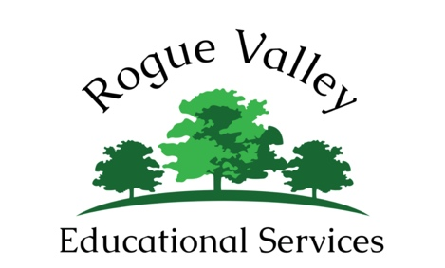

Summer Camp Contract

I, ________________________, parent of ______________________ understand the following:

Campers will be required to bring their own lunches, sunscreen, and water (please avoid sugary drinks, and pack a well-balanced, healthy lunch)
Please label ALL jackets, hats, sunscreen, water bottles, etc.

Expectations:

Have fun!! Come to camp with a positive attitude!!
Be respectful to adults, fellow campers, and other people in the community.
Kind, respectful language will be used at all times.
Boundaries must be respected as a matter of safety, both physical and emotional.
Violence of any kind will not be tolerated.
Campers must stay with the group at all times.
Campers must make a reasonable effort to participate in camp activities

Campers will be given 2 warnings. Parents will be contacted after the second warning. If, at any time, any of the above expectations are violated, the 3rd time RVES will contact parents and ask them to pick up their child until the following day. If expectations are violated for 2 days during the week parents will be asked to keep their child home for the remainder of the week. No refunds will be given.

Set your child up for success:

Make sure your child has had a well-balanced breakfast before camp - Hungry campers are cranky campers and you are much more likely to get a call if your child is cranky!

Think you packed a good lunch? Double it. These kids will be outside running and inside using their minds all day. They need a lot of food!

Go over expectations EVERY morning before they get to camp. Consistency is key. If your child knows we are all on the same page with expectations he/she is much more likely to make good decisions during the day.

PARENT SIGNATURE: _____________________________________________

CAMPER SIGNATURE: _____________________________________________

